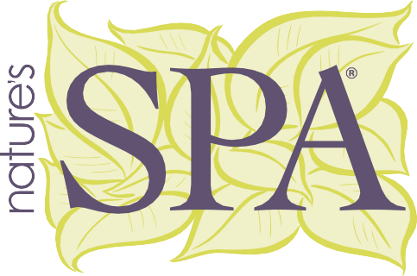
Let’s get social!
We’ve created suggested social media post copy for you to use on your social media channels. Please make sure to include #ParamountSleep in all your posts regarding Paramount Sleep Company products and tag us as we would love to
share your posts!
You can find Paramount Sleep across these social media platforms:
@ParamountSleep
@Paramount_Sleep @ParamountSleep Paramount Sleep Company @ParamountSleep

FACEBOOK | INSTAGRAM
Springs in your mattress got you down? Try the Nature's Spa Original collection by @ParamountSleep. It features a foam core and natural layers of Talalay latex, silk, wool, and cashmere, with a luxurious designer knit quilt top. Put a spring in your step, not in your back! #BetterSleep #ParamountSleep | Springs in your mattress got you down? Try the Nature's Spa Original collection by @Paramount_Sleep. It features a foam core and natural layers of Talalay latex, silk, wool, and cashmere, with a luxurious designer knit quilt top. Put a spring in your step, not in your back! #BetterSleep #ParamountSleep
The Nature's Spa collection by @ParamountSleep balances comfort, support and pressure relief for deep, restorative sleep. Made in the USA with natural, high-quality materials like Talalay latex, CertiPUR-US foam, cooling gel quilting foam, and a microcoil comfort layer, this  mattress rejuvenates your body naturally. #BetterSleep #ParamountSleep | The Nature's Spa collection by @Paramount_Sleep balances comfort, support and pressure relief for deep, restorative sleep. Made in the USA with natural, high-quality materials like Talalay latex, CertiPUR-US foam, cooling gel quilting foam, and a microcoil comfort layer, this  mattress rejuvenates your body naturally. #BetterSleep #ParamountSleep
As part of @ParamountSleep’s redesigned Nature’s Spa collection, the hybrid units are compression hand-tufted, encased in natural latex, and feature 13 ¾-gauge zoned pocket spring that provides more lower back support and better pressure relief in the shoulder and knee regions. #BetterSleep #ParamountSleep | As part of @Paramount_Sleep’s redesigned Nature’s Spa collection, the hybrid units are compression hand-tufted, encased in natural latex, and feature 13 ¾-gauge zoned pocket spring that provides more lower back support and better pressure relief in the shoulder and knee regions. #BetterSleep #ParamountSleep
@ParamountSleep’s Nature’s Spa collection features environmentally friendly materials carefully selected to provide optimum pressure relief, temperature regulation and support. Our mattresses conform instantly to the body’s unique shape, pushing back where the body needs it most. Generous natural and sustainable fillings are the essence of the Nature’s Spa collection. Layers of natural cotton, silk, wool, and cashmere, recycled steel, natural latex, and CertiPUR-US® certified foams create a remarkable feel. #BetterSleep #ParamountSleep | @Paramount_Sleep’s Nature’s Spa collection features environmentally friendly materials carefully selected to provide optimum pressure relief, temperature regulation and support. Our mattresses conform instantly to the body’s unique shape, pushing back where the body needs it most. Generous natural and sustainable fillings are the essence of the Nature’s Spa collection. Layers of natural cotton, silk, wool, and cashmere, recycled steel, natural latex, and CertiPUR-US® certified foams create a remarkable feel. #BetterSleep #ParamountSleep

